**Applied Statistics - Lab 2**

**Date of performance:** 24-08-2021

**Date of Submission:** 25-08-2021

**SAP Id:** 500083382

**Name:** Anurag Singh

**Batch:** AI&ML B2

**Problem:** Find the range, standard deviation and variance for each of the variables. (Discuss measures of dispersion for Nominal and Ordinal Data)

**Dataset:**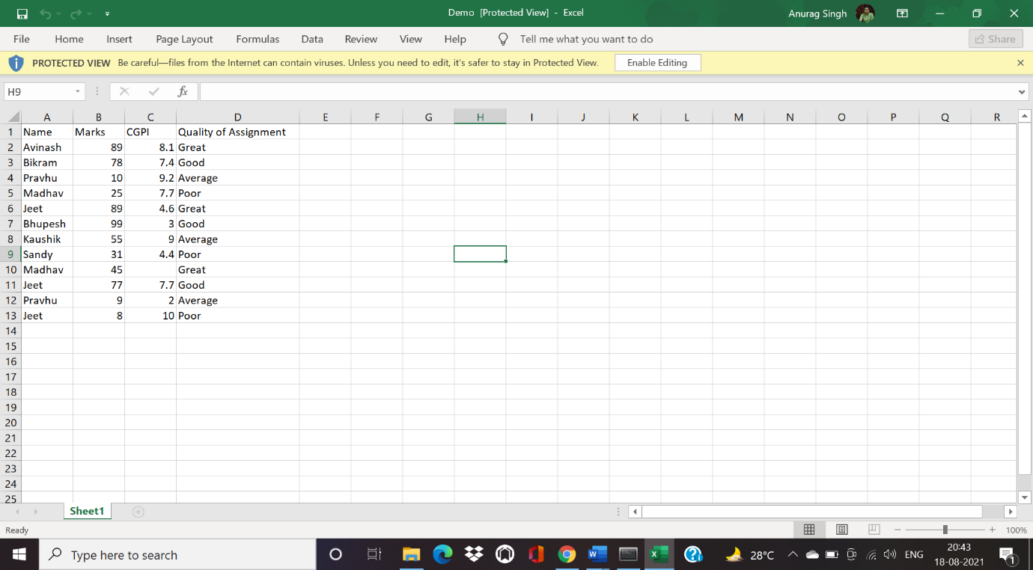

**Code to read the file as a data frame in Python:**

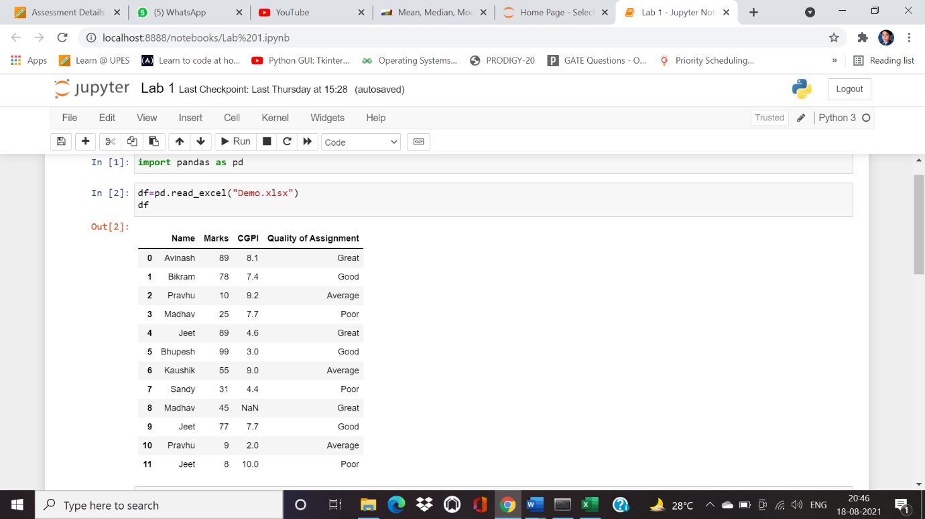

**Range, standard deviation and variance for each of the variables**

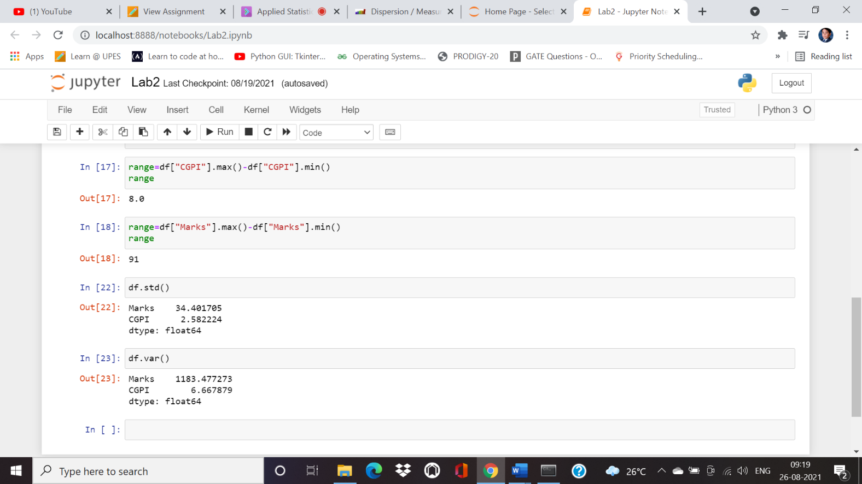

**Discuss measures of dispersion for Nominal and Ordinal Data**

Data measured at the nominal level: Because all three measures of dispersion require data to be ranked or summed, none of them are appropriate for data measured at the nominal level. Data measured at the ordinal level: The range and interquartile range are appropriate. The interquartile range is usually preferable, as it is more informative than the range.